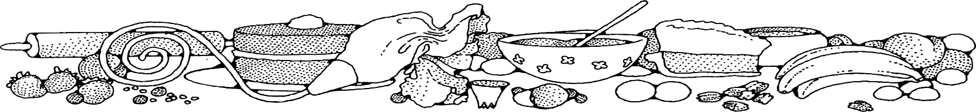
SUGar free Zucchini raisin nut Bread
COMPLIMENTS OF Jeannie Strickler - Cassville
DIRECTIONS
Bread:
- Preheat oven to 350 degrees. Spray loaf pans with non-stick spray.
- In a large bowl, combine margarine, Splenda and eggs using a wire whisk. Stir in applesauce and vanilla extract. Add flour, baking powder, cinnamon and salt. Mix gently just to combine.
- Fold in zucchini and donated walnuts.
- Evenly spread batter into prepared loaf pans.
- Bake for 40 to 46 minutes or until a toothpick inserted in center comes out clean.
- Cool completely.

Ingredients
Bread:
- 1 cup margarine
- 3 cups Splenda
- 4 eggs
- 1 cup unsweetened applesauce
- 4 teaspoons vanilla
- 6 cups flour
- 2 tablespoons + 2 teaspoons baking powder
- 2 teaspoons ground cinnamon
- 2 teaspoons salt
- 4 cups zucchini
- 1 cup chopped walnuts (donated)

NOTES
Makes 4 loaves.

