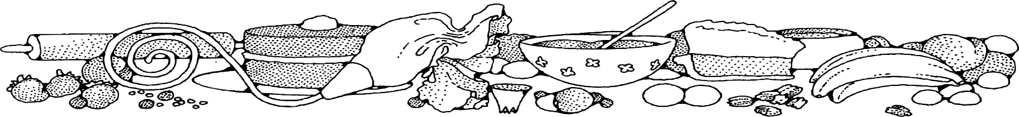
sugar-free lemon squares
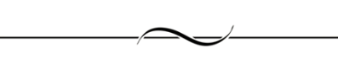
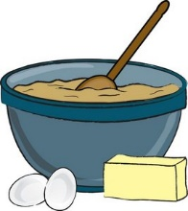
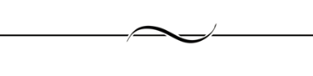
COMPLIMENTS OF Jeannie strickler - cassville
Ingredients
Bars:
- 2 cups + 4 tablespoons flour
- 2 ½ cups Splenda
- 1 cup butter
- 4 eggs
- 1 cup lemon juice
- 1 teaspoon baking powder
- ½ teaspoon salt
- 4 teaspoons grated lemon peel (optional)

DIRECTIONS
Bars:
- Preheat oven to 350 degrees. Spray square pans with non-stick spray.
- In a large bowl, combine, 2 cups flour, and ½ cup Splenda. Add butter and blend well using two forks or a pastry blender until mixture is crumbly.
- Pat mixture in pan building up a 1/4 –inch edge along sides. Bake for 12 minutes.
- In mixer, combine 2 cups Splenda and 4 tablespoons flour, eggs, lemon juice, baking powder, salt, and lemon peel, if desired. Beat on high for 3 minutes until light and fluffy.
- Spread mixture over baked crust.
- Continue baking for 25-30 minutes until filling is set.
- Cool completely.

NOTES
These bars are light and lemony!

