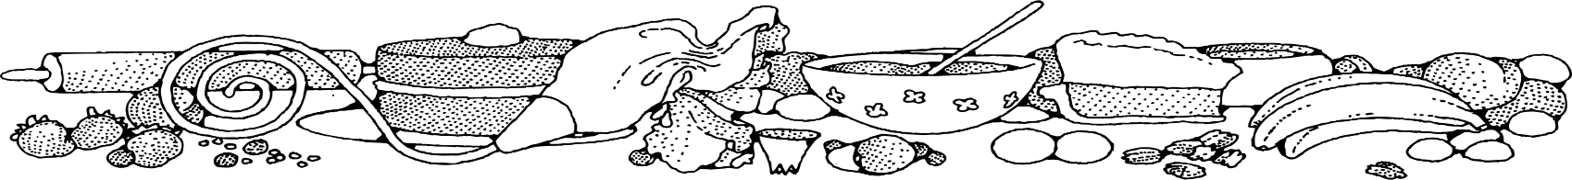
sugar-free carrot Cake
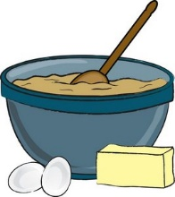
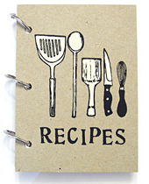
COMPLIMENTS OF Jeannie strickler - cassville
Ingredients
Cake:
- 1 cup butter
- 2 ¼ cups of Splenda
- 9 eggs
- 3 cups milk
- 4 ½ teaspoons vanilla
- 4 ½ cups biscuit mix
- 4 ½ teaspoon cinnamon
- 6 cups carrots
- 1 cup walnuts (donated)

Glaze:
- 1 lb. powdered sugar
- ½ cup milk
- ½ teaspoon vanilla

DIRECTIONS
Cake:
- Preheat oven to 350 degrees. Spray 1 sheet pan with non-stick spray.
- In a large bowl, combine margarine, Splenda and eggs using a wire whisk. Stir in milk and vanilla extract. Add biscuit mix and cinnamon. Mix well to combine.
- Fold in carrots and walnuts.
- Evenly spread batter into prepared pan.
- Bake for 33 to 37 minutes or until a toothpick inserted in center comes out clean.
- Cool completely.

Glaze:
- In a medium bowl, place powder sugar, milk and vanilla. Mix until smooth.
- Using a piping bag, drizzle glaze back and forth over cake sparingly.

NOTES
This is a good way to get folks to eat more carrots. The cake is not only good for you, but it tastes good too!

