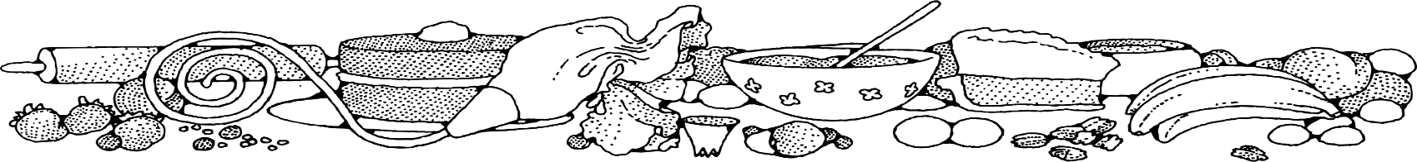
SUGAR-FREE BREAD PUDDING
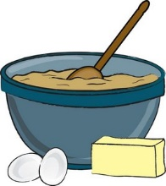
COMPLIMENTS OF Nora Taylor - FOrt
DIRECTIONS

Bread Pudding:
- Soak raisins in water.
- Preheat oven to 350 degrees. Spray loaf pans with non-stick spray.
- Cut bread into cubes.
- Mix together milk, eggs, Splenda, margarine and vanilla. Stir to combine.
- Pour mixture onto bread cubes and stir until bread is moist.
- Drain excess water off raisins and fold raisins into bread mixture.
- Fill prepared pans. Bake uncovered 30-45 minutes or until toothpick inserted in center comes out clean.
Glaze:
- In a medium bowl, place powder sugar, milk and vanilla. Whisk until smooth.
- Using the whisk, drizzle small amount of glaze over bread pudding.

Ingredients

Bread Pudding:
- 1 (20 oz) loaf of bread
- 1 quart milk
- 3 eggs
- 2 cups Splenda
- 3 tablespoons margarine, melted
- 2 tablespoons vanilla
- 1 cup raisins (optional)
Glaze:
- 1 pound powdered sugar
- ½ cup milk
- ½ teaspoon vanilla

NOTES
Go easy on the glaze to reduce the amount of sugar on the dessert.

