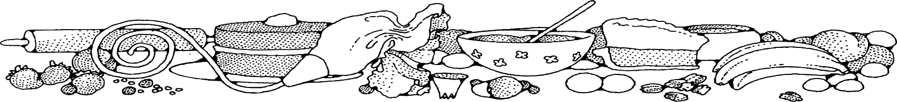
Sugar-free Banana Cookies
COMPLIMENTS OF Nora Taylor- Fort
Ingredients
Cookie:
- 3 ripe bananas
- 2 cups rolled oats
- 1 cup donated dried fruit
- 1/3 cup vegetable oil
- 1 teaspoon vanilla

DIRECTIONS
Cookie:
- Preheat oven to 350 degrees. Line sheet pan with parchment paper.
- In a bowl, mash the bananas. Stir in oats, dried fruit, oil and vanilla. Mix well and allow to sit for 15 minutes.
- Scoop out about 1 teaspoon of mixture and place on prepared pan.
- Bake 15-20 minutes until lightly golden brown.
- Allow cookies to cool completely.

NOTES
Dried cherries, raisins, cranberries, etc… would be delicious when included in this recipe.

