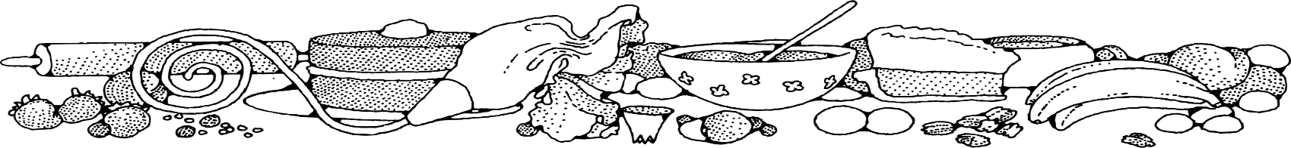
sugar-free BANANA Cake
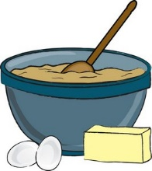
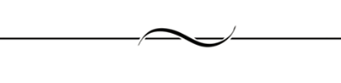
COMPLIMENTS OF Jeannie strickler - cassville
Ingredients
Cake:
- 8 tablespoons butter
- 2 ¼ cups of Splenda
- 6 eggs
- 6 medium mashed bananas
- 1 ½ cups water
- 4 ½ teaspoons vanilla
- 4 ½ cups biscuit mix

DIRECTIONS
Cake:
- Preheat oven to 350 degrees. Spray 1 sheet pan with non-stick spray.
- In a large bowl, combine margarine, Splenda and eggs using a wire whisk. Stir in mashed bananas, water and vanilla extract. Add biscuit mix. Mix gently just to combine.
- Evenly spread batter into prepared pan.
- Bake for 20 to 24 minutes or until a toothpick inserted in center comes out clean.
- Cool completely.

NOTES
This cake may also be topped with a dusting of powdered sugar or a dollop of reduced-calorie whipped topping.

