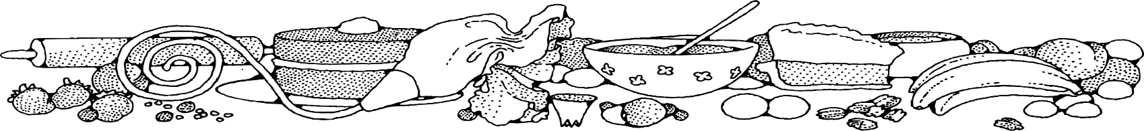
sugar-free Applesauce Raisin Bread
COMPLIMENTS OF Jeannie strickler - cassville
Ingredients
Bread:
- 4 cups water
- 4 cups raisins
- 4 cups flour
- 2 teaspoons baking soda
- 3 teaspoon cinnamon
- 1 teaspoon nutmeg
- 2 cups unsweetened applesauce
- 4 eggs
- 4 tablespoons liquid sweetener
- 1 ½ cup oil
- 2 teaspoons vanilla

DIRECTIONS
Bread:
- Preheat oven to 350 degrees. Spray loaf pans with non-stick spray.
- Add raisins and water to a pot. Cook until water evaporates.
- In a large bowl, combine flour, baking soda, cinnamon, and nutmeg.
- In another bowl, combine applesauce, eggs, liquid sweetener, oil and vanilla.
- Add dry mixture to the wet mixture. Stir in water soaked raisins.
- Place approximately 1 ½ cups of batter into prepared loaf pans. Pan should fill half way.
- Bake for 25 minutes turning half way through cook time or until a toothpick inserted in center comes out clean.
- Cool completely.

NOTES
Any dried fruit will work in this recipe in place of the raisins.

