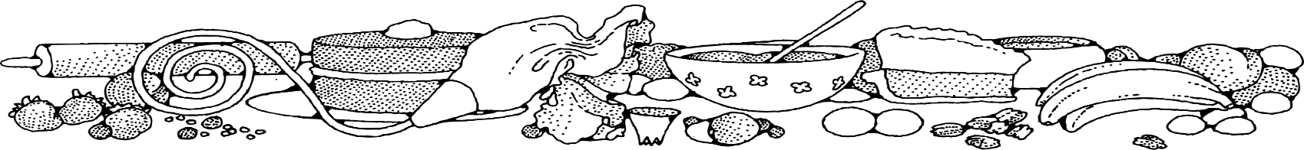**Scones (5 lb. bag)**



**Directions**

**Scones:**

1. Preheat convection oven to 325 degrees. Fan speed on low. Line sheet pan(s) with parchment paper.
2. In a bow mixing, combine baking mix and sugar.
3. Mix in butter with your hands or pastry blender until butter is pea size.
4. Beat eggs and milk together in bowl and pour over dry ingredients until just blended.
5. Fold in optional ingredient(s) gently. (If using dried fruit, soak in water to reconstitute)
6. Turn dough out onto floured work surface and pat into a large rectangle 3/4-inch thick. Cut rectangle into 3x3 squares and then cut each square into 2 triangles. Place triangles on prepared pans. Reshape and cut dough as needed.
7. Bake 7 minutes, then turn pan in oven. Bake an additional 7 minutes or until scones are golden.
8. Combine ingredients for glaze and drizzle over scones.

**Ingredients**

**Scones:**

* 1 (5#) bag baking/biscuit mix (obtain from OFH)
* 1 ½ cups sugar
* 1 pound butter
* 11 eggs
* 1 ½ cups milk
* 3 cups fruit or other opt. ingreds.

**Glaze:**

* 2 cups powdered sugar
* 6 tablespoons milk
* 1 teaspoon vanilla

**Optional OFH/Donated Ingredients:**

* blueberries, raspberries, cherries, craisins, orange or lemon zest, etc…
* chocolate, cinnamon chips etc…
* nuts

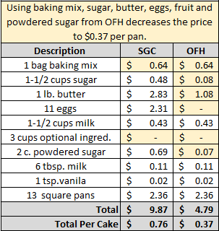****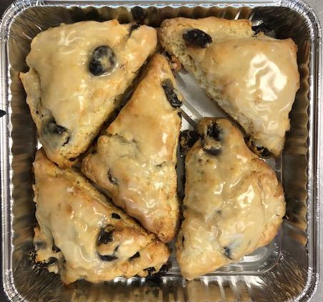****

Notes

Makes approximately 65 scones. Five scones fit into a square pan for home delivery.