**Old Fashioned Soft Pumpkin Cookies **



**Directions**

**Cookies:**

1. Preheat convection oven to 350 degrees. Fan speed on low. Line sheet pan(s) with parchment paper.
2. Combine all dry ingredients
3. Cream together margarine and sugar. Add eggs, vanilla and pumpkin. Mix well.
4. Gradually beat in dry ingredients. Refrigerate for 2-3 hours.
5. Using a one-ounce scoop, scoop cookie dough and roll in powdered sugar and place onto prepared sheet pan.
6. Bake 8-10 minutes or until edges are golden. Cool.

**Cost breakdown:**

**Ingredients**

**Cookies:**

* 5 cups flour
* 2 teaspoons baking soda
* 2 teaspoons baking powder
* 2 teaspoons ground cinnamon
* 1 teaspoon ground nutmeg
* 1 teaspoon salt
* 3 cups sugar
* 1 cup margarine or butter, softened
* 2 cups or 1 (15 oz.) can pumpkin
* 2eggs
* 2 teaspoons vanilla extract
* 2 cups powdered sugar

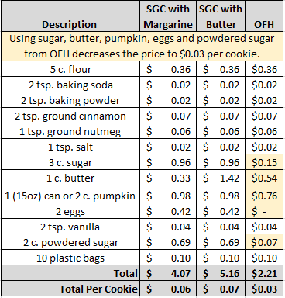**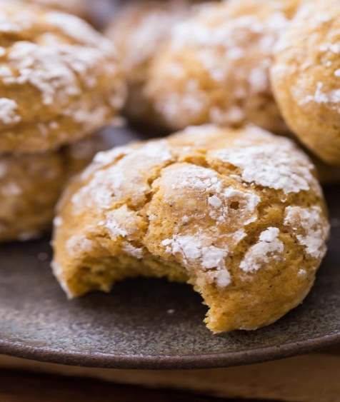******

Notes

Makes approximately 72 cookies.

Package 7 cookies in a 10x14 plastic bag for home delivery.