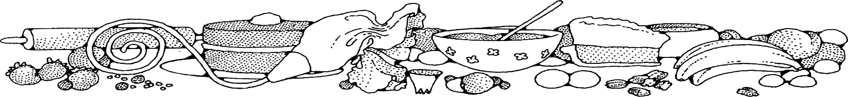 **Sugar Cookies (25 lb. bag)**



**Ingredients**

**Cookies:**

* 1 bag of sugar cookie mix
* 7 ½ cups cold water

**Optional OFH or Donated Ingredients:**

* colored sugar
* sprinkles

**Note:** If using only 5 pounds of cookie mix, add 1 ½ cups cold water. Yield will be 72 three-inch cookies.

**Directions**

**Cookies:**

1. Preheat convection oven to 325 degrees. Fan speed on low.
2. Put 2/3 of the water into a mixing bowl and add mix. (Add sprinkles if desired).
3. Using paddle attachment, mix ½ minute on low speed. Scrape bowl and paddle.
4. While on low speed, gradually add remaining water. Scrape bowl and paddle.
5. Mix ½ minute on low speed (Do not overmix).
6. Line sheet pans with parchment paper. Using a #40 scoop (1 ½ tablespoon scoop) drop cookies onto prepared pans. Cookies may be rolled in colored sugar if desired).
7. Bake approximately 11-12 minutes.

**Cost breakdown:**

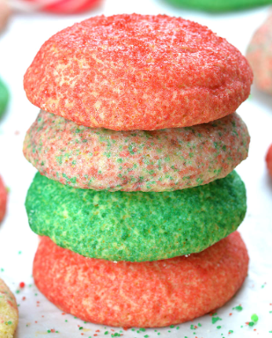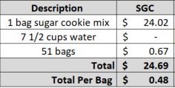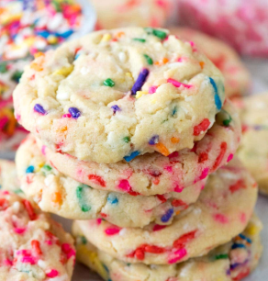****

Notes

Makes approximately 360 three-inch cookies. Package 7 cookies in a 10x14 plastic bag for home delivery.