**Snickerdoodle Cookies **



**Directions**

**Cookies:**

1. Preheat convection oven to 350 degrees. Fan speed on low.
2. Line sheet pan(s) with parchment paper.
3. In a small bowl mix 1 cup sugar and the cinnamon. Set aside.
4. Cream together margarine, sugar and brown sugar (butter does make cookies flatten while baking).
5. Add eggs and vanilla. Mix well.
6. Combine remaining dry ingredients, then stir into wet ingredients.
7. Using a two-ounce scoop, portion cookies onto prepared sheet pan. Roll each cookie in the cinnamon/sugar mixture.
8. Bake 8 minutes or until slightly browned.

**Cost breakdown:**

**Ingredients**

**Cookies:**

* 3 cups sugar divided
* 4 teaspoons cinnamon
* 1-1/3 cups light brown sugar
* 2 cups margarine or butter
* 4 teaspoons vanilla
* 4 eggs
* 6 cups flour
* 2 teaspoons baking soda
* 1 teaspoon cream of tarter
* 1 teaspoon salt

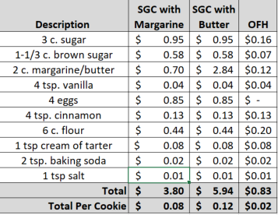**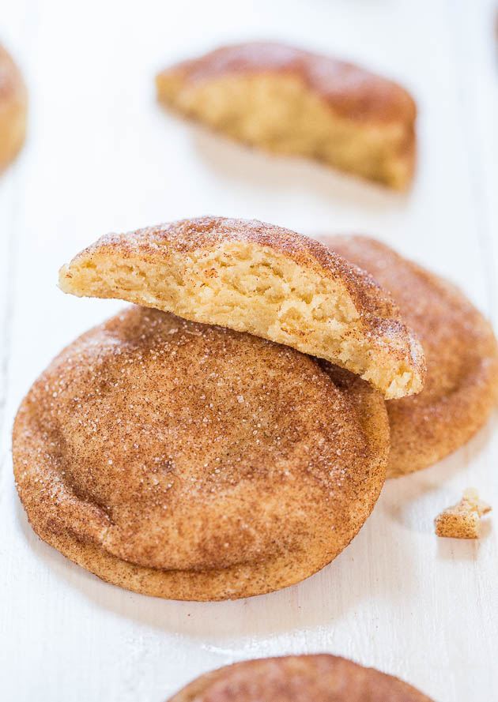******

Notes

Makes approximately 50 cookies.

Package 7 cookies in a 10x14 plastic bag for home delivery.