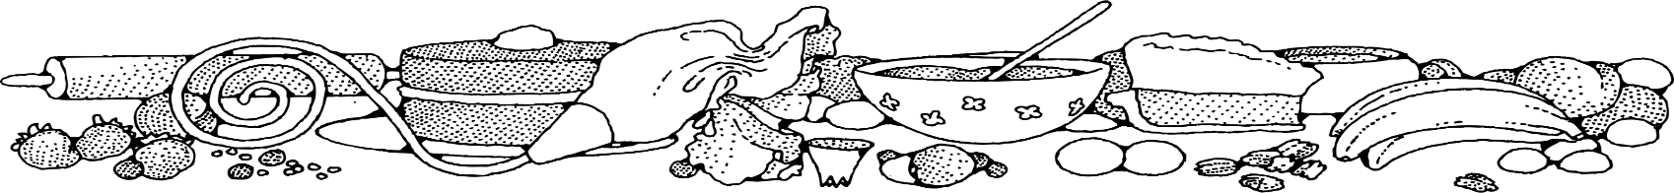**Peanut Butter Cookies **



**Directions**

**Cookies:**

1. Preheat convection oven to 350 degrees. Fan speed on low.
2. Line sheet pan(s) with parchment paper.
3. Cream together margarine, sugar and brown sugar (butter does make cookies flatten while baking).
4. Add eggs, vanilla and peanut butter. Mix well.
5. Combine remaining dry ingredients, then stir into wet ingredients.
6. Using a two-ounce scoop, portion cookies onto prepared sheet pan. Flatten cookies with a fork dipped in sugar.
7. Bake 8-10 minutes or until edges are golden.

**Cost breakdown:**

**Ingredients**

**Cookies:**

* 3 cups sugar
* 3 cups light brown sugar
* 3 cups margarine or butter
* 4 teaspoons vanilla
* 8 eggs
* 3 cups peanut butter
* 9 cups flour
* 6 teaspoons baking soda
* ½ teaspoon salt

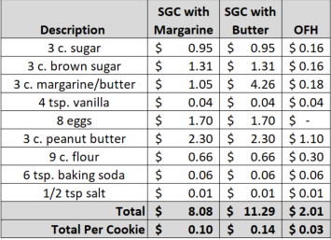**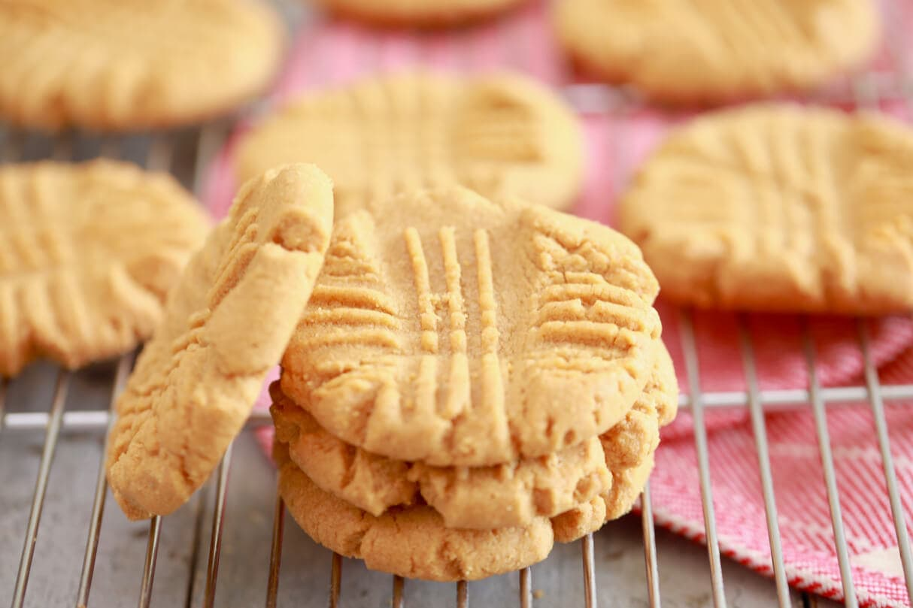******

Notes

Makes approximately 80 cookies.

Package 7 cookies in a 10x14 plastic bag for home delivery.