**Oatmeal Cookies **



**Directions**

**Cookies:**

1. Preheat convection oven to 350 degrees. Fan speed on low.
2. Line sheet pan(s) with parchment paper.
3. Cream together margarine and brown sugar (butter does make cookies flatten while baking).
4. Add eggs and vanilla and mix well.
5. Stir in oats, flour, soda and salt.
6. Using a two-ounce scoop, portion cookies onto prepared sheet pan.
7. Bake 8-10 minutes or until golden brown.

**Cost breakdown:**

**Ingredients**

**Cookies:**

* 3 cups light brown sugar
* 2 cups margarine or butter
* 2 teaspoons vanilla
* 3 eggs
* 4 cups oats
* 3 cups flour
* 2 teaspoons baking soda
* ½ teaspoon salt

**Optional OFH or Donated Ingredients:**

* chopped nuts
* coconut
* raisins or craisins
* chocolate chips

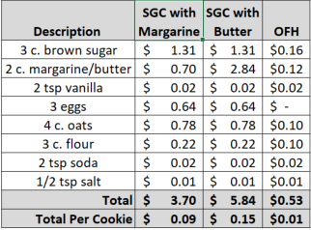**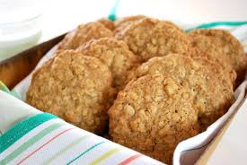******

Notes

Makes approximately 40 cookies.

Package 7 cookies in a 10x14 plastic bag for home delivery.