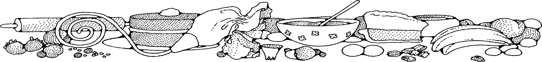**Coconut Macaroons**



**Directions**

**Cookies:**

1. Preheat convection oven to 325 degrees. Fan speed on low.
2. Line sheet pan(s) with parchment paper.
3. In a large bowl, add egg whites, sugar, salt and vanilla extract.
4. With mixer, beat egg white mixture until thick and frothy, about 2-3 minutes.
5. Add coconut to egg white mixture, and stir until combined.
6. With a one-ounce scoop, portion cookies and place 1-2" apart on parchment.
7. Bake for about 8-12 minutes, or until the macaroons are golden.

**Cost breakdown:**

**Ingredients**

**Cookies:**

* 8 egg whites
* 1 cup sugar
* 2 teaspoons vanilla
* pinch of salt
* 8 cups shredded coconut

**Note:** Coconut should be obtained through OFH or donation and not purchased from SGC.

****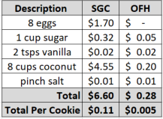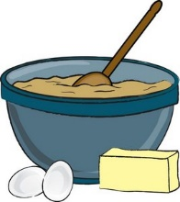

Notes

Makes approximately 60+ cookies.

Package 7 cookies in a 10x14 plastic bag for home delivery.