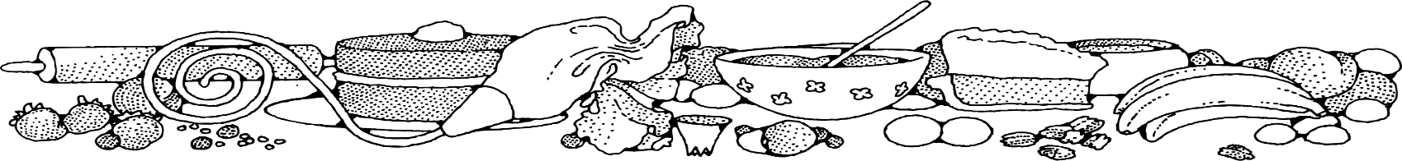**Chocolate Chip Cookies **



**Directions**

**Cookies:**

1. Preheat convection oven to 350 degrees. Fan speed on low.
2. Line sheet pan(s) with parchment paper.
3. Cream together butter and brown sugar.
4. Add eggs and vanilla and stir in.
5. Add baking mix and stir to combine. Fold in chocolate chips.
6. Using a 1-ounce scoop, place cookies onto prepared sheet pan. Flatten cookies slightly with the palm of your hand.
7. Bake 8-10 minutes or until edges are golden.

**Cost breakdown:**

**Ingredients**

**Cookies:**

* 2 ½ cups butter (may sub margarine in place of butter)
* 5 cups brown sugar
* 3 tablespoons vanilla
* 5 eggs
* 1 (5#) bag biscuit baking mix
* 5 cups chocolate chips

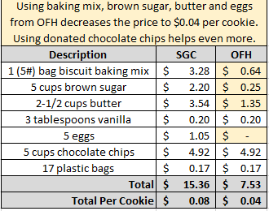**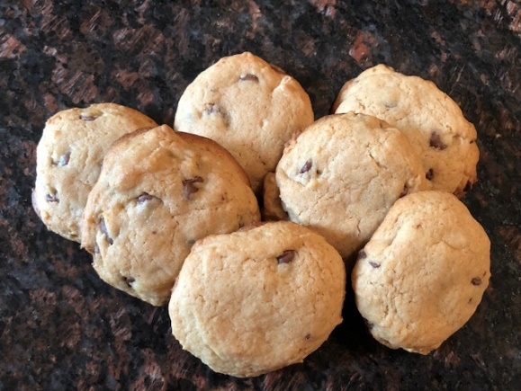******

Notes

Makes approximately 123 cookies.

Package 7 cookies in a 10x14 plastic bag for home delivery.