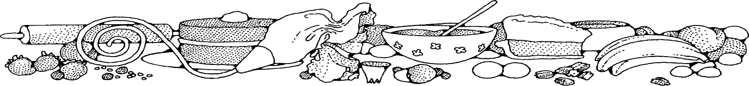**Cereal Bars**

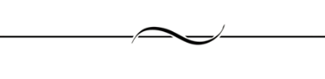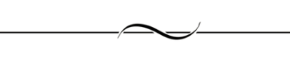

**Directions**

**Bars:**

1. Spray 6 square pans with non-stick spray.
2. Melt butter using stove over low heat (may use microwave).
3. Add marshmallows and stir until they are completely melted (microwave on high and stir after every minute until melted).
4. Quickly add cereal and stir until cereal is coated.
5. Evenly divide mixture into the 6 prepared pans.
6. Spray the top of mixture with non-stick spray and press to evenly spread out the cereal mixture.

**Cost breakdown:**

**Ingredients**

**Bars:**

* 9 tablespoons butter
* 3 (10oz) bags marshmallows
* 18 cups cereal

**Note:** Cereal and marshmallows should be obtained through OFH or donation and not purchased from SGC.

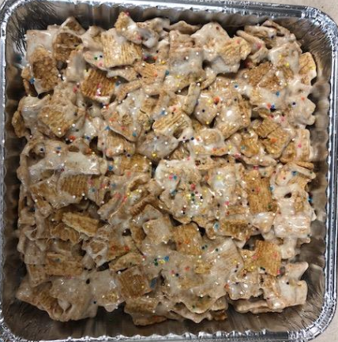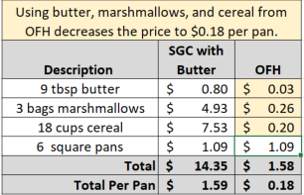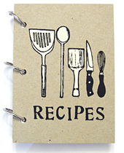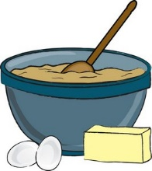

Notes

Makes approximately 6 square pans. Package in a 10x14 plastic bag for home delivery.