**Butterscotch Refrigerator Cookies **



**Directions**

**Cookies:**

1. Preheat convection oven to 375 degrees. Fan speed on low.
2. Line sheet pan(s) with parchment paper.
3. Combine eggs, brown sugar and margarine or butter (butter does make cookies flatten while baking).
4. Add muffin mix and stir until well combined.
5. Wrap dough in plastic wrap and refrigerate for two hours or until firm.
6. Using a one-ounce scoop, portion cookies onto prepared sheet pan.
7. Using the palm of your hand, press cookies to ½ inch thickness.
8. If using optional ingredients, press cookies in the chopped nuts or coconut before baking.
9. Bake 7-9 minutes.

**Cost breakdown:**

**Ingredients**

**Cookies:**

* 8 eggs
* 4 cups packed light brown sugar
* 8 ounces softened margarine or butter
* 5 lb. bag plain muffin mix

**Optional OFH or Donated Ingredients:**

* chopped nuts
* coconut

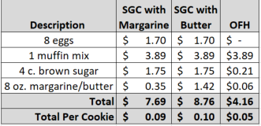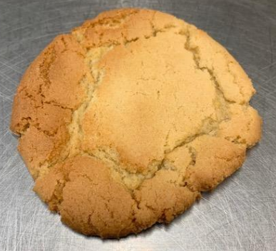****

Notes

Makes approximately 84+ cookies.

Package 7 cookies in a 10x14 plastic bag for home delivery.