**Cake with Canned Fruit (5 lb. bag)** 



**Ingredients**

**Cake:**

* 2 (5#) bag cake mix (spice, white, or yellow)
* 6 cups water
* 4 cups fruit liquid
* 1 (#10) can fruit (apples, applesauce, fruit cocktail, mandarin oranges or peaches)

**Glaze:**

* 4 cups powdered sugar
* 3/4 cup milk
* 2 teaspoons vanilla

**Cost breakdown:**

**Directions**

**Cake:**

1. Preheat convection oven to 325 degrees. Fan speed on low.
2. Prepare 20 loaf pans with non-stick spray.
3. Drain fruit and reserve liquid (if liquid does not measure 4 cups, then add water to reach that level).
4. In a bow mixing, combine cake mix, fruit liquid and water (if using applesauce, use only 6 cups water and 8 cups of applesauce).
5. Dice fruit into small pieces and add to mixture.
6. Evenly divide batter into the 20 prepared pans (approx. 3 eight-ounce scoops).
7. Bake 15 minutes, then turn pan in oven. Bake an additional 10-15 minutes until toothpick when inserted comes out clean.

**Glaze:**

1. In a small bowl, mix powdered sugar, milk and vanilla.
2. Drizzle or brush glaze onto cake.

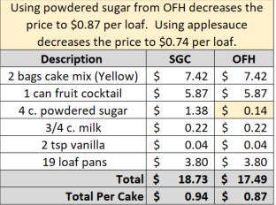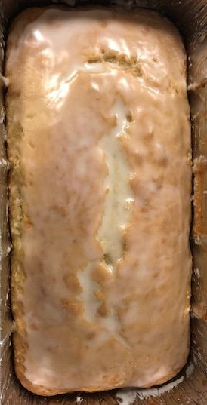****

Notes

Makes approximately 20 loaves.

Package in a 10x14 plastic bag for home delivery.