**Pudding Cake (5 lb. bag)**



**Ingredients**

**Cake:**

* 2 (5#) bag cake mix (any flavor)
* 1 (#10) can pudding (chocolate or vanilla)
* 6 cups water

**Glaze:**

* 4 cups powdered sugar
* ¾ cup milk
* 2 teaspoons vanilla

**Cost breakdown:**

**Directions**

**Cake:**

1. Preheat convection oven to 325 degrees. Fan speed on low.
2. Prepare 20 loaf pans with non-stick spray.
3. In a bow mixing, combine cake mix, pudding and water.
4. Evenly divide batter into the 20 prepared pans (approx. four 8-ounce scoops).
5. Bake 20 minutes, then turn pan around in oven. Bake an additional 10 minutes or until toothpick when inserted comes out clean.

**Glaze:**

1. In a small bowl, mix powdered sugar, milk and vanilla.
2. Drizzle or brush glaze onto cake.

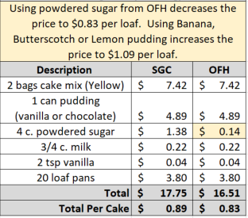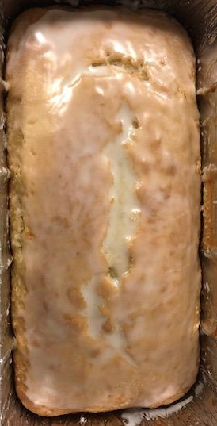****

Notes

Makes approximately 20 loaves.

Package in a 10x14 plastic bag for home delivery.