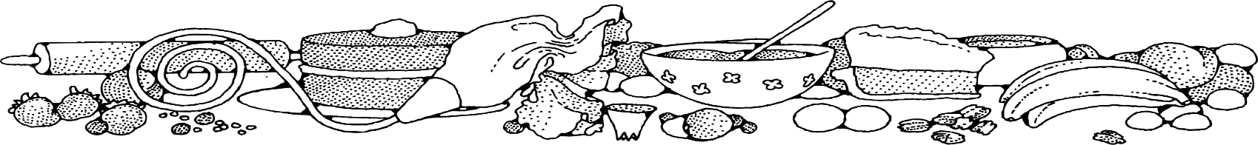**Poke Cake (15-16 oz. box)**



**Directions**

**Cake:**

1. Preheat convection oven to 325 degrees. Fan speed on low. Prepare tins with non-stick spray.
2. In a bow mixing, combine cake mix, water, oil & eggs.
3. Evenly divide batter into 18 loaf pans.
4. Bake 10 minutes, turn pan(s) in oven. Bake an additional 10 minutes or until toothpick when inserted comes out clean. Allow cakes to cool.
5. When cooled, poke holes all over cakes with a fork.
6. Make jello according to pkg. directions.
7. Pour gelatin mixture evenly over the 18 cakes slowly so that gelatin gets absorbed into holes.
8. Make whipped topping according to pkg. directions and spread ½ cup on each cake.

**Cost breakdown:**

**Ingredients**

**Cake:**

* 9 boxes white or yellow cake mix (see note below)
* 9 cups water
* 3 cups oil
* 18 eggs

**Note:** Obtain cake mix from OFH or as a donation to make this dessert affordable.

**Gelatin Mixture:**

* 1 (24-ounce) bag jello any flavor
* 1 gallon hot water

**Topping:**

* 1 (1#) bag whipped topping mix
* 1 quart water

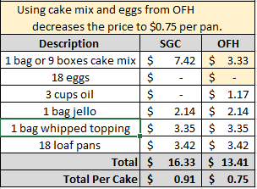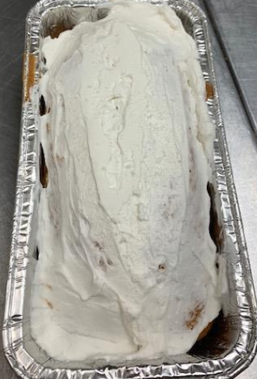****

Notes

Makes approximately 18 loaves.

Package in a 10x14 plastic bag for home delivery.