**Cake Mix Cookies (5 lb. bag)**



**Directions**

**Cookies:**

1. Preheat convection oven to 325 degrees. Fan speed on low.
2. Line sheet pan(s) with parchment paper.
3. In a mixing bowl, add softened margarine or butter and eggs to combine (butter does make cookies flatten while baking).
4. Add cake mix and combine (if using a devil’s food cake, add 6 tablespoons of water and mix).
5. Mix in any optional ingredients.
6. Using a one-ounce scoop, portion cookies onto prepared sheet pan (if using powdered sugar or cinnamon sugar, roll cookies in sugar).
7. Bake approximately 7 minutes.

**Cost breakdown:**

**Ingredients**

**Cookies:**

* 4 eggs
* 1 pound softened margarine or butter
* 5 lb. bag cake mix (white, yellow or devil’s food)
* Water as needed

**Optional OFH or Donated Ingredients:**

* chocolate chips
* candy pieces
* sprinkles
* dried fruit
* chopped nuts
* coconut
* powdered sugar (roll in)
* cinnamon sugar (roll in)

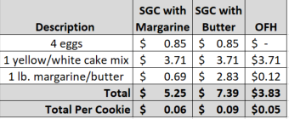********

Notes

Makes approximately 84+ cookies.

Package 7 cookies in a 10x14 plastic bag for home delivery.