** Cake Mix Cookies (15-16 oz. box)**



**Directions**

**Cookies:**

1. Preheat convection oven to 325 degrees. Fan speed on low.
2. Line sheet pan(s) with parchment paper.
3. In a large bowl, combine the cake mix, oil, and eggs.
4. Mix in any optional ingredients.
5. Using a one-ounce scoop, portion cookies onto prepared sheet pan. If using powdered sugar or cinnamon sugar, roll cookies in sugar.
6. Bake approximately 7 minutes.

**Cost breakdown:**

**Ingredients**

**Cookies:**

* 2 eggs
* 1/3 cup vegetable oil
* 1 box of cake mix (any flavor)

**Optional OFH or Donated Ingredients:**

* chocolate chips
* candy pieces
* sprinkles
* dried fruit
* chopped nuts
* coconut
* powdered sugar (rolled in)
* cinnamon sugar (rolled in)

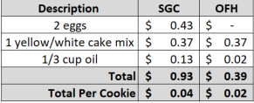****

Notes

Makes approximately 22+ cookies.

Package 7 cookies in a 10x14 plastic bag for home delivery.