**Coffee Cake (5 lb. bag)**



**Ingredients**

**Topping:**

* 4 cups brown sugar
* ¼ cup cinnamon
* 2 cups melted butter

**Cake:**

* 1 (5#) bag baking mix (see note below)
* 9 cups milk
* 8 eggs
* 2 2/3 cups sugar
* 1 cup oil

**Note:** Obtain baking (biscuit) mix from OFH or as a donation to make this dessert affordable.

**Directions**

**Cake:**

1. Preheat convection oven to 350 degrees. Fan speed on low. Prepare 8 loaf pans with non-stick spray.
2. In a small bowl, combine brown sugar and cinnamon. Set aside.
3. In a large bowl, combine baking mix, milk, eggs, sugar and oil.
4. Place 1 cup of batter into the prepared pans. Sprinkle ¼ cup topping on batter, then lightly cover with melted butter. Repeat with 1 cup of batter, ¼ cup of topping and melted butter.
5. Bake 15 minutes, then turn pan around in oven. Bake an additional 10 minutes or until toothpick when inserted comes out clean.

**Cost breakdown:**

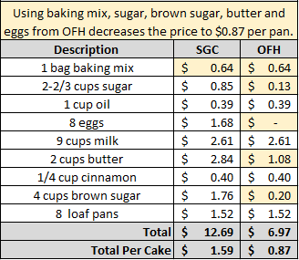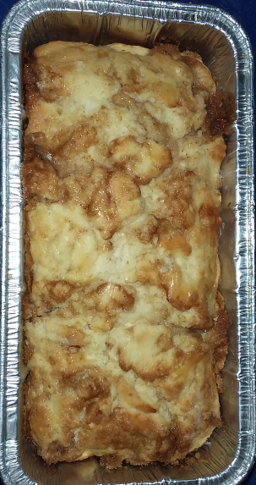****

Notes

Makes approximately 8 loaves.

Package in a 10x14 plastic bag for home delivery.