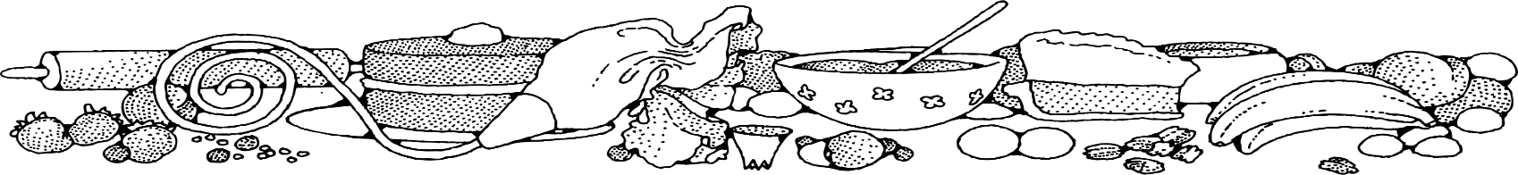**Cake Brownie (5 lb. bag)**



**Ingredients**

**Cake:**

* 1 (5#) bag brownie mix (see note below)
* 2 cups water
* 4 eggs

**Note:** Obtain brownie mix from OFH or as a donation to make this dessert affordable.

**Optional OFH or Donated Ingredients:**

* peanut butter (1/3 cup)
* chocolate chips
* candy pieces
* nuts

**Directions**

**Cake:**

1. Preheat convection oven to 300 degrees. Fan speed on low.
2. Prepare 8 square pans with non-stick spray.
3. In a bow mixing, combine brownie mix, eggs and water.
4. Place two scoops of batter (#6 scoop) into the prepared pans.
5. Bake 15 minutes, then turn pan around in oven. Bake an additional 10 minutes or until toothpick when inserted comes out clean.

**Cost breakdown:**

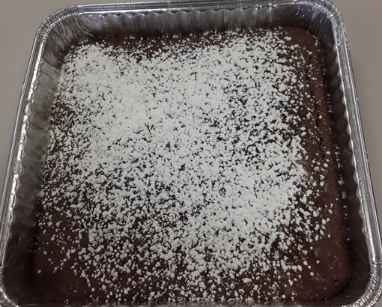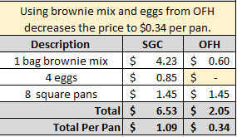****

Notes

Makes approximately 8 square pans.

Package in a 10x14 plastic bag for home delivery.