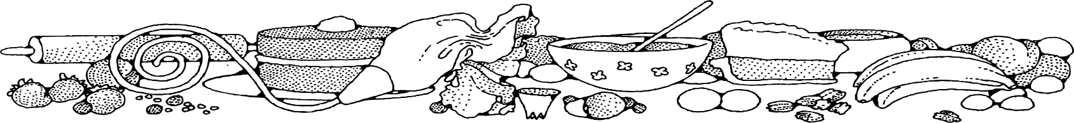**Basic Cake (5 lb. bag)**



**Directions**

**Cake:**

1. Preheat convection oven to 325 degrees. Fan speed on low.
2. Prepare 9 loaf pans with non-stick spray.
3. In a bow mixing, combine cake mix and water.
4. Evenly divide batter into the prepared pans.
5. Bake 10 minutes, then turn pan around in oven. Bake an additional 10 minutes or until toothpick when inserted comes out clean.

Glaze:

1. In a small bowl, mix powdered sugar, milk and vanilla.
2. Drizzle or brush glaze onto cake.

**Cost breakdown:**

**Ingredients**

**Cake:**

* 1 (5#) bag cake mix (any flavor)
* 5 cups water

**Glaze:**

* 2 cups powdered sugar
* 6 tablespoons milk
* 1 teaspoon vanilla

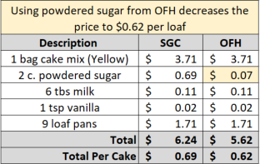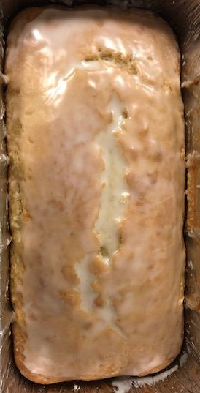****

Notes

Makes approximately 9 loaves.

Package in a 10x14 plastic bag for home delivery.