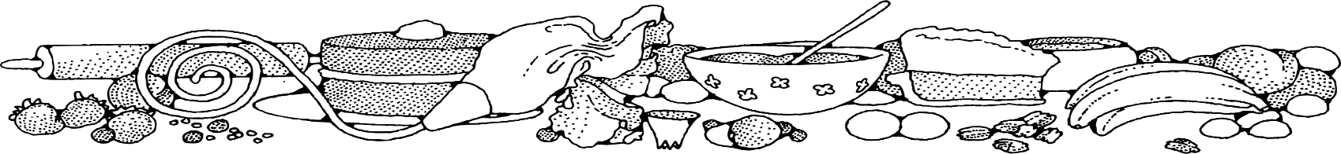**Bread with Fresh Fruit/Vegetables**



**Ingredients**

**Bread:**

* 1 (5#) bag plain muffin mix
* 5 cups water
* 1/2 teaspoon nutmeg
* 2 teaspoons cinnamon

**OFH or Donated Fresh Fruit**

* Smashed, small diced or grated fresh fruit/vegetables (5-6 bananas, peaches, pears or apples) (3-4 cups berries) (5-6 cups zucchini or carrots)

**Optional OFH or Donated Ingredients:**

* chopped nuts
* raisin or craisins
* coconut

**Directions**

**Bread:**

1. Preheat convection oven to 350 degrees. Fan speed on low.
2. Prepare 10 loaf pans with non-stick spray.
3. In a bowl, combine water, muffin mix, nutmeg and cinnamon (if using zucchini, decrease water to 4 cups).
4. Add desired fruit or vegetable.
5. Mix in any optional ingredients.
6. Evenly divide batter into the 10 prepared pans. (Approx. 3 eight-ounce scoops)
7. Bake 25 minutes, then turn pan in oven. Bake an additional 10-15 minutes until toothpick comes out clean when inserted.

**Cost breakdown:**

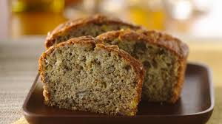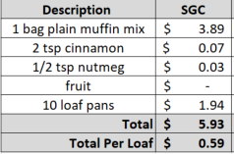****

Notes

Makes approximately 10 loaves.

Package in a 10x14 plastic bag for home delivery.